**VAISHALI BOKADIYA**

**DAY 10 ASSESSMENT**

**JSON, NUMPY AND PANDAS**

**Reading CSV Data using Pandas:**

There are three ways of reading CSV data using pandas:

* **read_csv():**

Code:

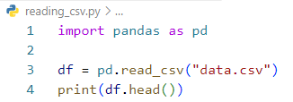

Output:

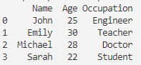

* **read_table():**

Code:

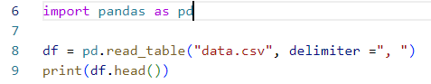

Output:

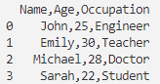

* **using csv module:**

Code:

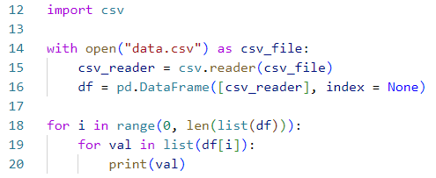

Output:

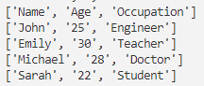

**Read Data from CSV Files to Pandas Dataframes:**

Data from the CSV files can be read using pandas.read_csv() method.

Code:

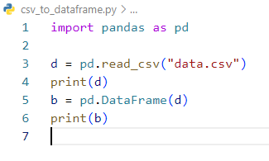

Output:

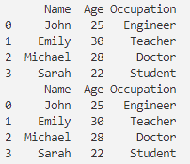

**Filter Data in Pandas Dataframe using query:**

Data in the python dataframes can be filtered using dataframe.query() method.

Code:

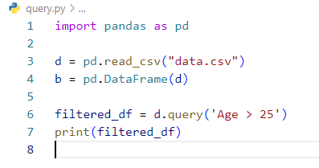

Output:



**Get Count by Age using Pandas Dataframe APIs:**

Data values can be counted in Pandas dataframes using .count() method.

Code:

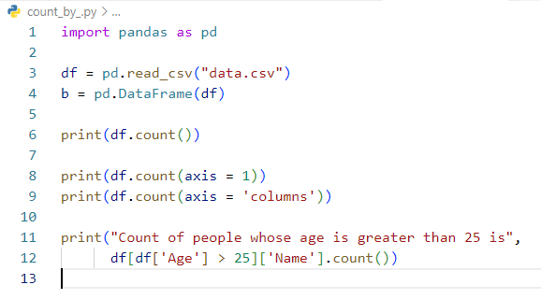

Output:

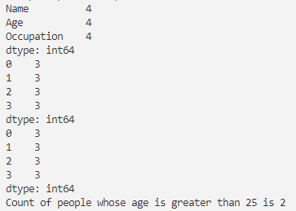

**Get count by Age and Occupation using Pandas Dataframe APIs:**

Code:

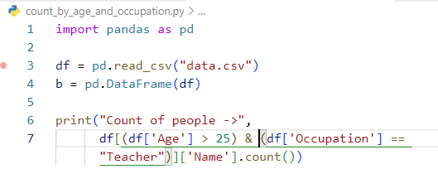

Output:



**Create Dataframes using dynamic column list on CSV Data:**

Code:

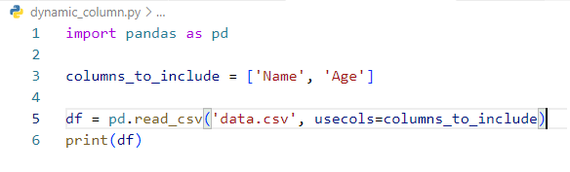

Output:

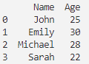

**Performing Inner Join between Pandas Dataframes:**

Inner join in Pandas dataframes can be done using pandas.merge() method. It has ‘on’ attribute in which we can specify the common column which has to be used to join the tables. It also has a “how” attribute in which we can specify how to join the table eg. Inner, if we want to do inner join on the table.

Code:

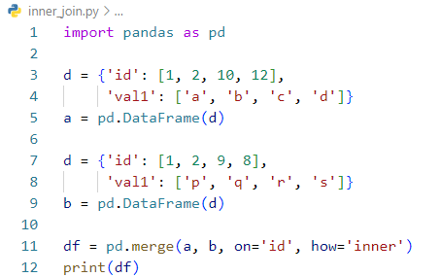

Output:



**Sort Data in Pandas Dataframes:**

Code:

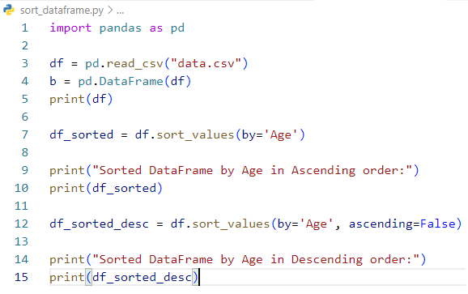

Output:

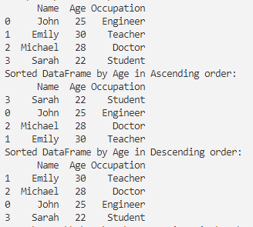

**Writing Pandas Dataframes to Files:**

Pandas dataframes can be written into csv file using dataframe.to_csv() method.

Code:

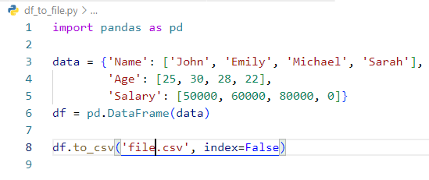

Output:

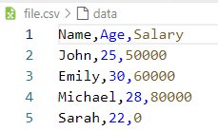

**Write Pandas Dataframes to JSON Files:**

Pandas dataframes can be written into json file using dataframe.to_json() method.

Code:

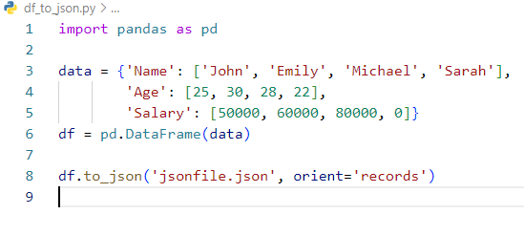

Output:

